**TCP Communication (Server Client)**

**Screen Shots of the project:**

**Welcome Screen:**

**Server:**

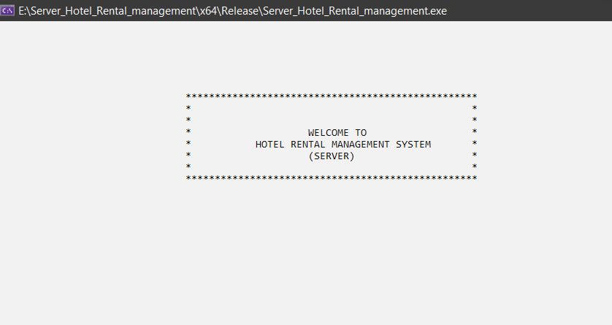

**Client 1: Client 2:**

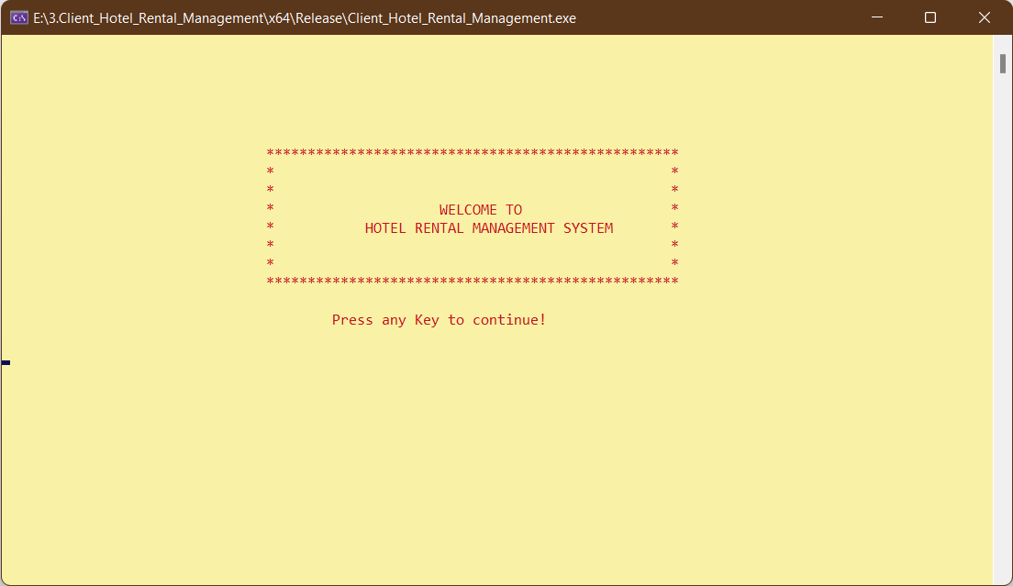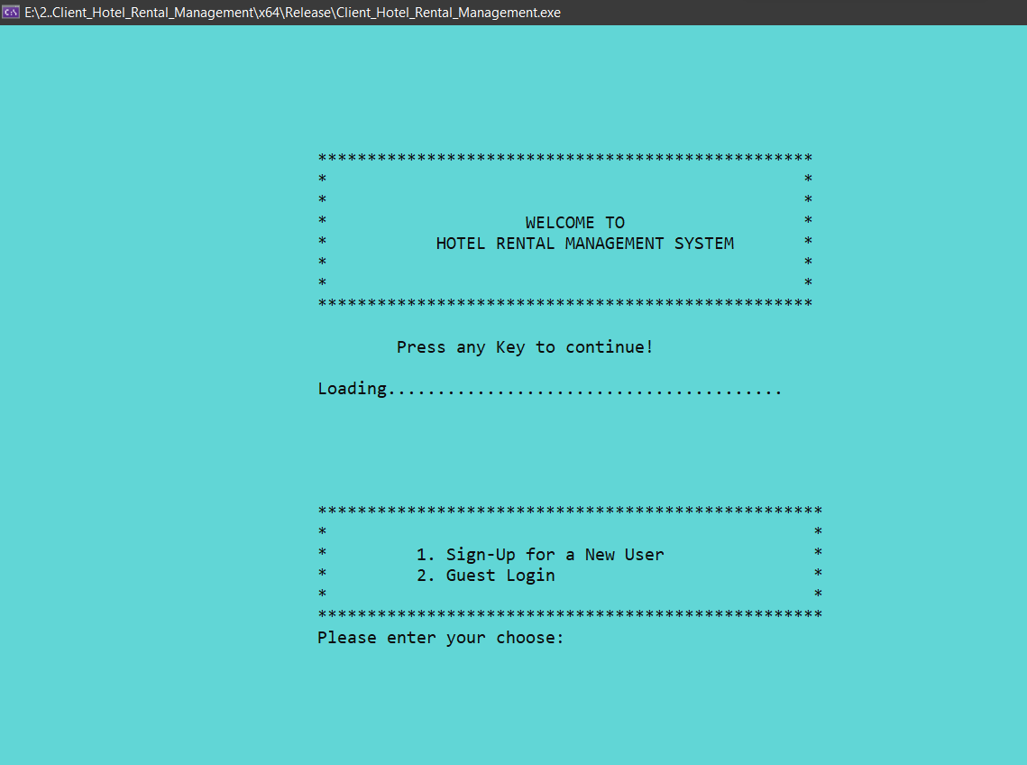

**Server:**



**Client 1:**

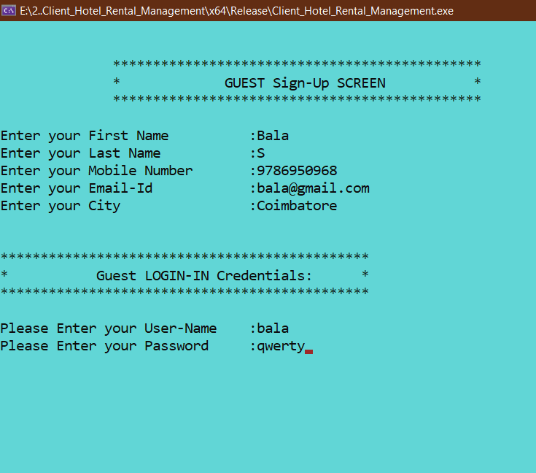

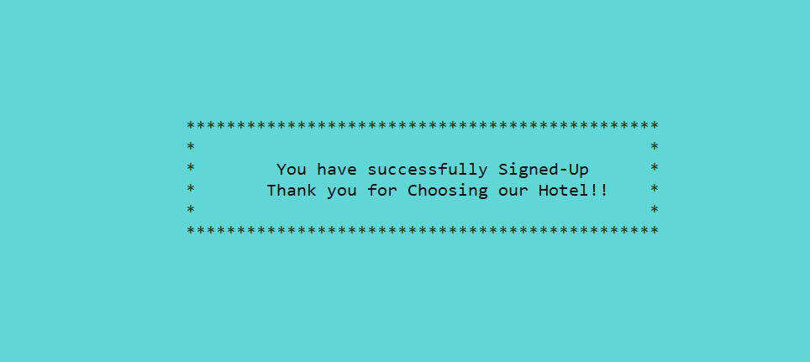

**Login Screen:**

**Server:**



**Client 1: Client 2:**

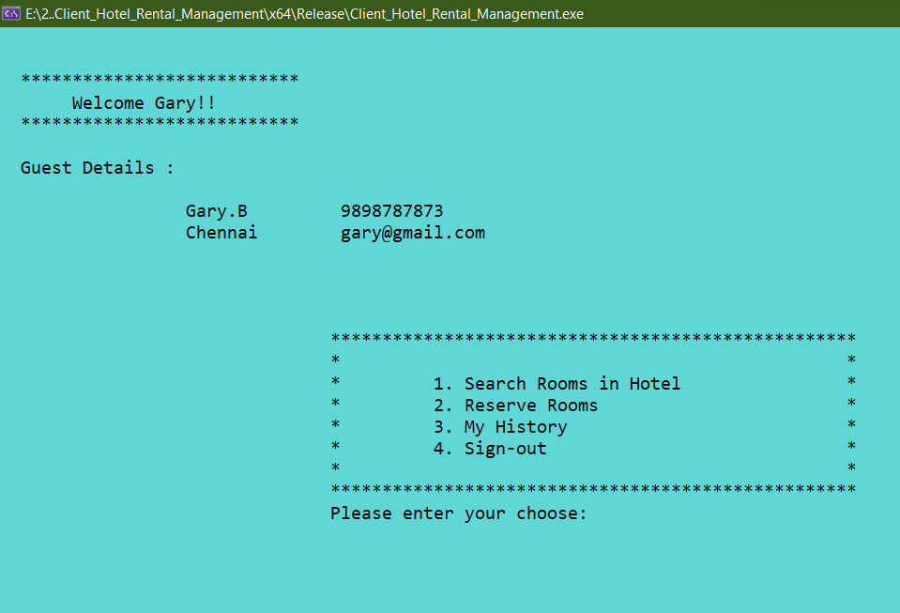

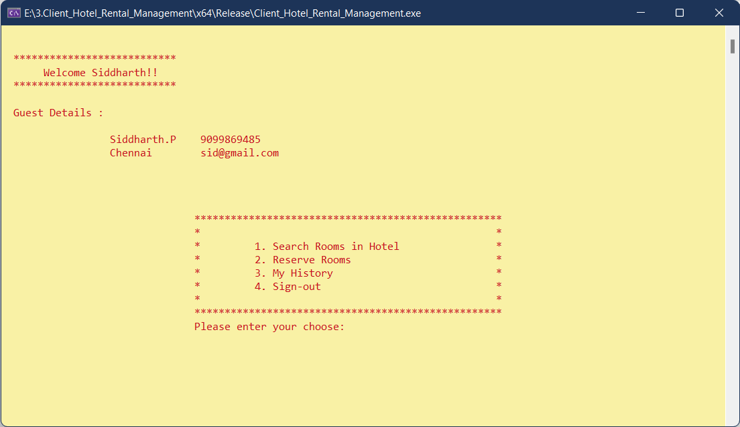

**Rooms Search Screen:**

**Client 1:**

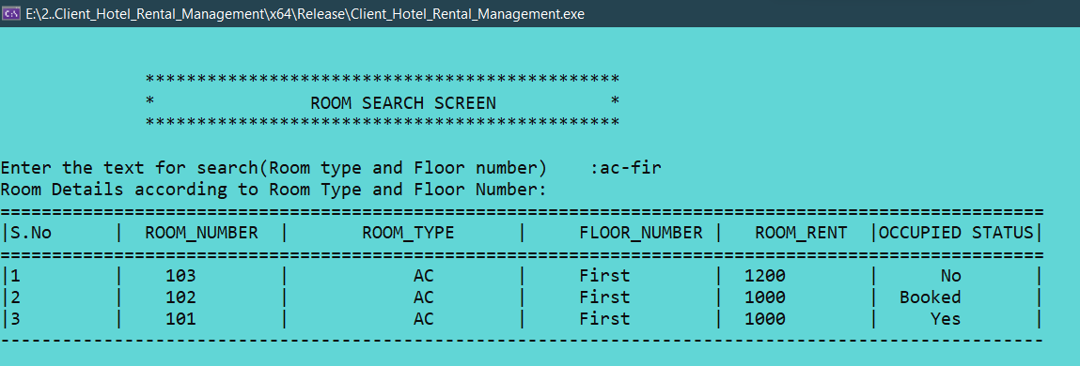

**Client 2:**

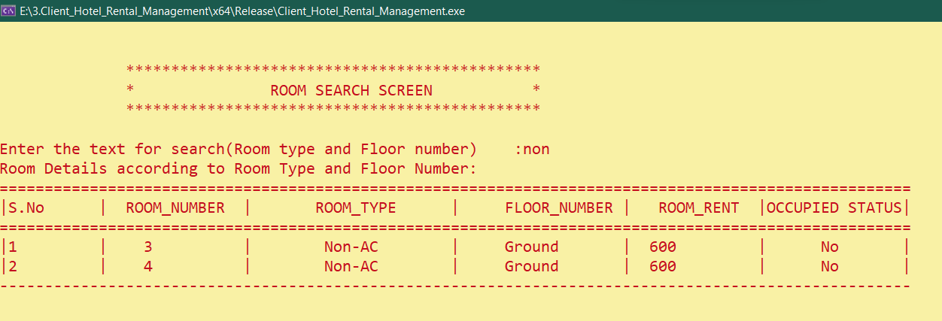

**Room Reservation Screen:**

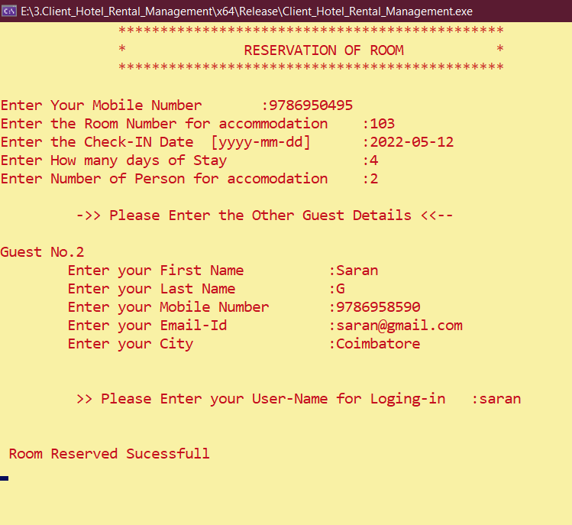

**In Guest Info Table:**

**Checks if the Rooms Is already Reserverd or Not:**

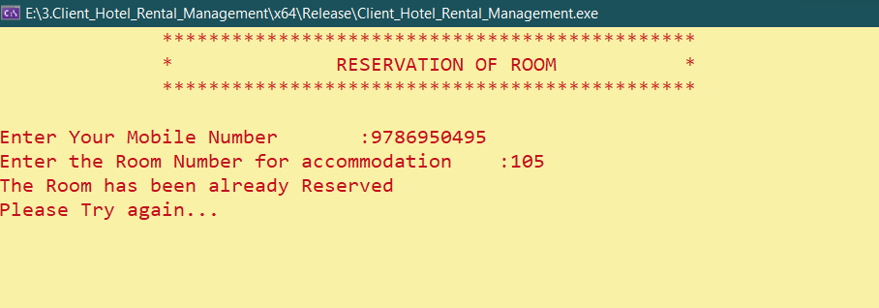

**Maximum Capacity Of Room:**

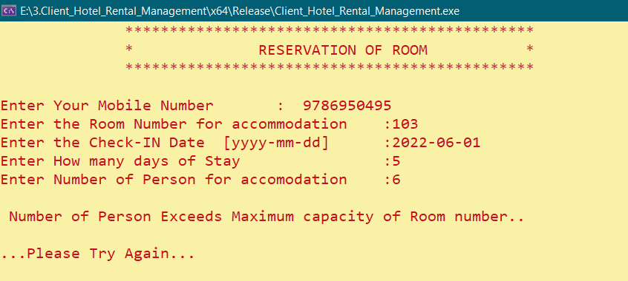

**Guest History Screen:**

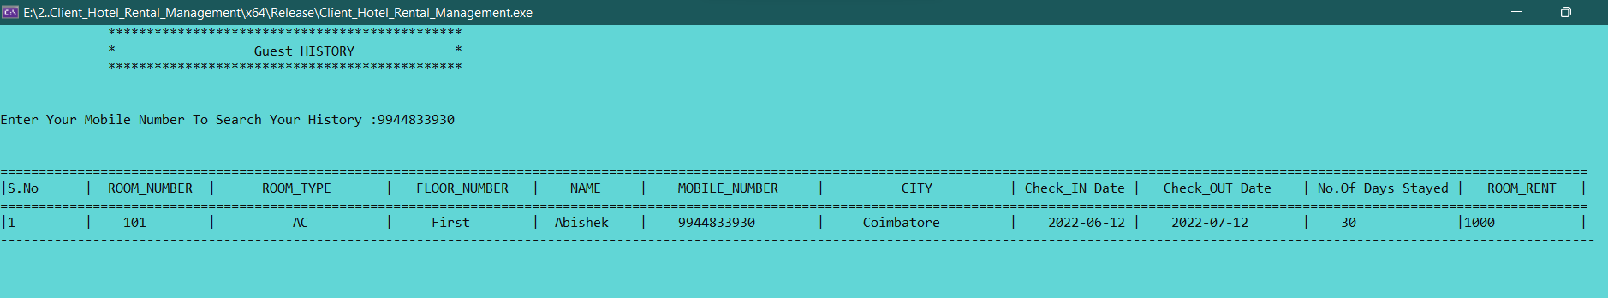

**Exit Screen:**

